File Handling Project Output Screenshots

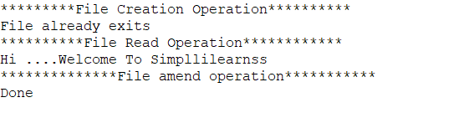

Created Files

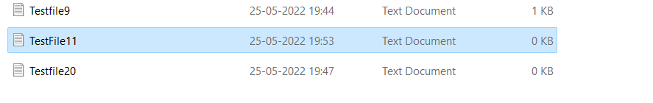

Reading Input File

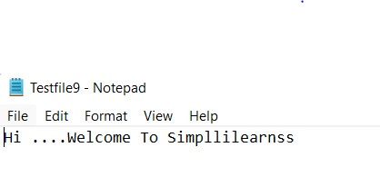

Newly Created File

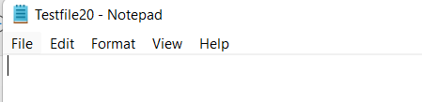

Amended File

